Name: Rajdeep Sarkar
Roll: UG/02/BTCSECSF/2023/008

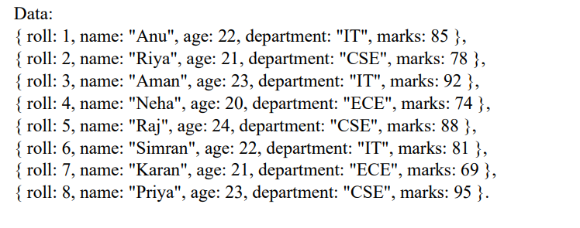
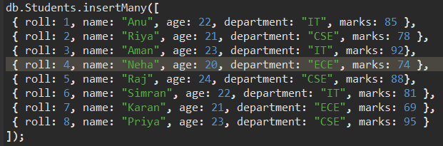

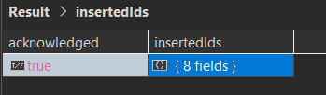

Q1. Display all documents
db.Students.find({});
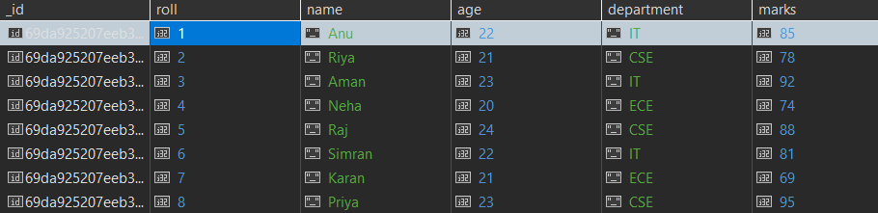

Q2. Find students from IT department
db.Students.find({department: "IT"});
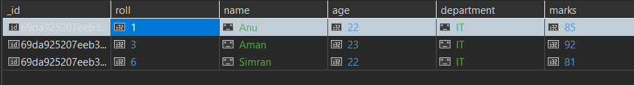
Q3. Find students with marks > 80
db.Students.find({marks: {$gt: 80}});
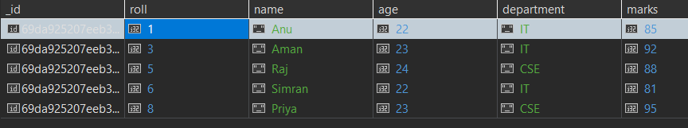
Q4. Insert one new student
db.Students.insertOne({roll: 9, name: "Rahul", age: 22, department: "CSE", marks: 82});
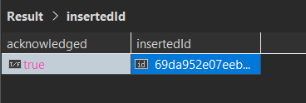
Q5. Update marks of Anu to 90
db.Students.updateOne({name: "Anu"}, {$set: {marks: 90}});
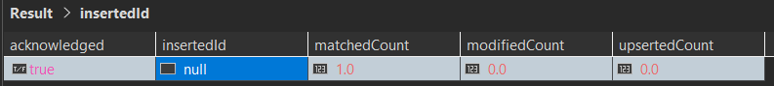
Q6. Add a new field "status: Pass" for all students
db.Students.updateMany({}, {$set: {status: "Pass"}});
Q7. Delete all students with marks < 70
db.Students.deleteMany({marks: {$lt: 70}});
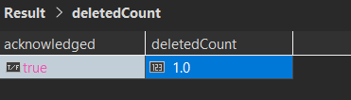
Q8. Count students in CSE department
db.Students.countDocuments({department: "CSE"});
Q9. Find total students in each department
db.Students.aggregate([{$group: {_id: "$department", total: {$sum: 1}}}]);
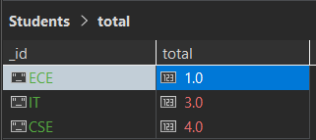
Q10. Find highest marks
db.Students.find().sort({marks: -1}).limit(1);
Q11. Find the second highest marks
db.Students.find().sort({marks: -1}).skip(1).limit(1);
Q12. Name starts with 'A' and marks > 80
db.Students.find({name: /^A/, marks: {$gt: 80}});
Q13. Dept-wise average marks, only for departments where avg > 80
db.Students.aggregate([
{$group: {_id: "$department", avgMarks: {$avg: "$marks"}}},
{$match: {avgMarks: {$gt: 80}}}
]);
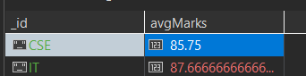
Q14. Marks between 75 and 90, sorted by marks ascending
db.Students.find({marks: {$gte: 75, $lte: 90}}).sort({marks: 1});
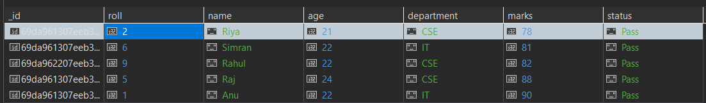
Q15. Add grade field based on marks (A for >= 80, B for < 80)
db.Students.updateMany({}, [
{$set: {
grade: {
$cond: {if: {$gte: ["$marks", 80]}, then: "A", else: "B"}
}
}}
]);

